***4. How to play the game***

***4.1 Pre preparations***

* You need MATLAB (2013 or below version) on your PC to play this game.
* Connect arduino Uno board to your PC and then establish a connection with Matlab.
* This code only works for the special firmware exits in ArduinoIO/ folder.

**And also need to flash the custom Arduino firmware to the board,**

**% that will be found on ArduinoIO/adio_blink/ folder**

* Open the code in the Matlab editor.

This game can be played without using Arduino board and LEDs.

If you want to **play it without using LEDs set the variable, set debug=1** Or set **debug=0 to use LEDs**

1. For the use of **mono colours** in LEDs

(Mention what should be done-jali)

1. For the use of **two colours** for two the players

(Mention what should be done-jali)

* Run the code by typing **‘prog4’** in the command window in Matlab. Or you can use the run button in the Matlab editor to run the code.

***4.2. Input methods***

This game can be played by either a **user input (1-9)** given by the user or by using **pushbuttons** in the PCB.

***4.2.1. Use of the keyboard***

Numbers in the keyboard of your PC which is in the right hand side can be used as inputs. The numbers represents the places in the Tic-Tac-Toe game.

When the code is run in Matlab command window, it will ask to enter the place to be locked for each player.

***4.2.2. Use of push buttons***

You may use push buttons to blink the LEDs .The push buttons are arranged to the same pattern of the numbers in the keyboard

* **This is how the LEDs are numbered for the game**
* **This is how the Pushbuttons are numbers for the game**

***4.3. Let’s play***

After running the code in Matlab, it will show a figure designed same as tic-tac-toe game.

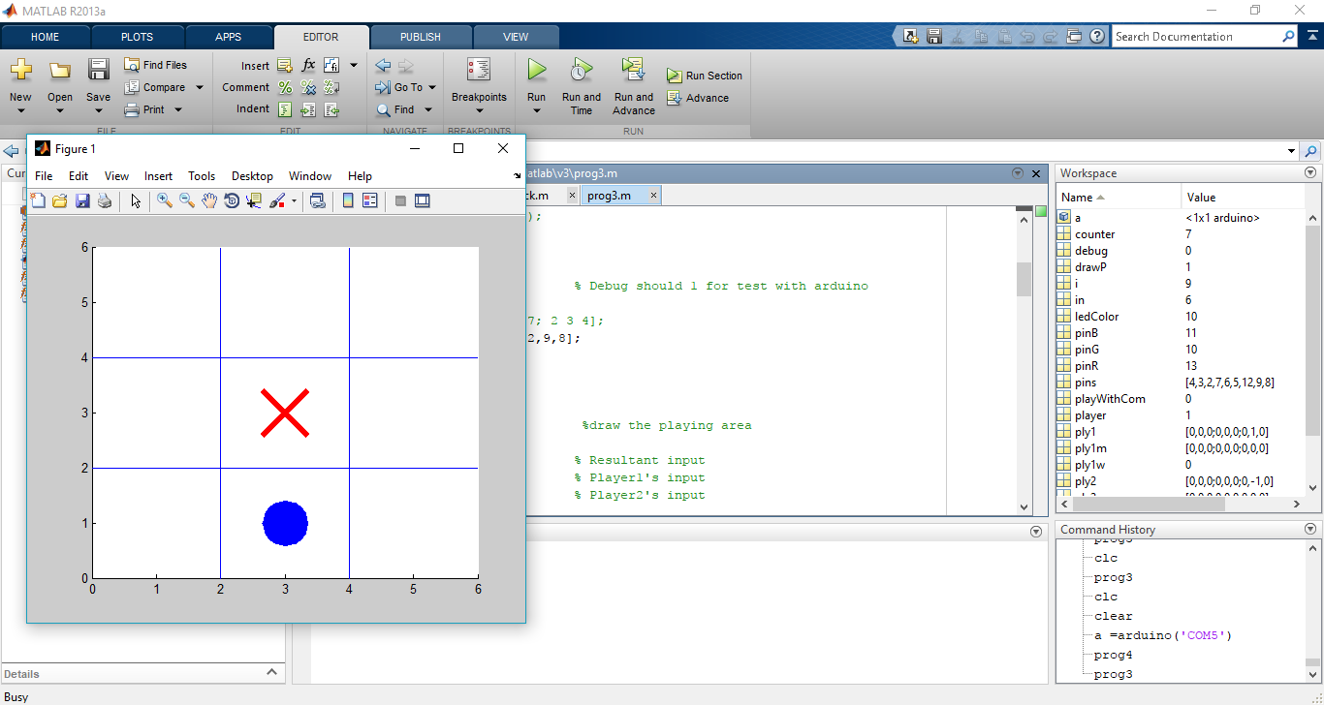

It will indicate the ongoing game clearly. it will show a red colored circle for the player 1‘s input and a blue colored cross for the player 2’s input. This can be used to identify the locked places for the corresponding players. **Moreover this figure can be used to play the game without Arduino board (debug mode= 1).**

Now two persons can play the game and they can choose who goes first, the first person who starts the game will play the chance of PLAYER 1. Both players will get the chance repeatedly to give inputs.

If you are using LEDs to play, note that PLAYER 2’s LEDs will Blink, PLAYER 1’S LEDs will be lighten without any blink.

The game will continue up to a player wins or the draw condition. Then the tic-tac-toe figure will display who has won or draw.

This game is designed same as the usual tic-tac-toe game, so the rules are the same for the winning and draw conditions. (Reference: *https://en.wikipedia.org/wiki/Tic-tac-toe*)

**Special modifications**

* If a player enters/inputs the already locked place, the player will be given the chance again to enter/input a correct place.

**Cautions**

* Note that the program will end if you input is not valid.

**Valid input is ONLY NUMBERS FROM 1-9**. Moreover it will be comfortable if the number pad in the right side of the keyboard is used.

* When playing the game with push buttons, it’s very important to press only one button at a time.

***3. Explanation of the Design***

Arduino Uno board is used as microcontroller development board. In this project, we need nine outputs (LEDs) and nine Button inputs. RGB LEDs (For our bonus milestone) are used, so there are 9x3=27 LEDs need to be controlled while taking 9 button readings.

Arduino Uno board had only 14 digital IO pins and 6 Analog Pins. So it is required to use special technologies to fulfill the above requirement.

*3.1 Controlling LEDs*

All Anodes of LEDs are connected to Digital IO ports through 470 Ohm resistors and other ends of each LEDs (R, G, B cathode pins) are connected each other separately and controlled by NPN transistor as shown below.

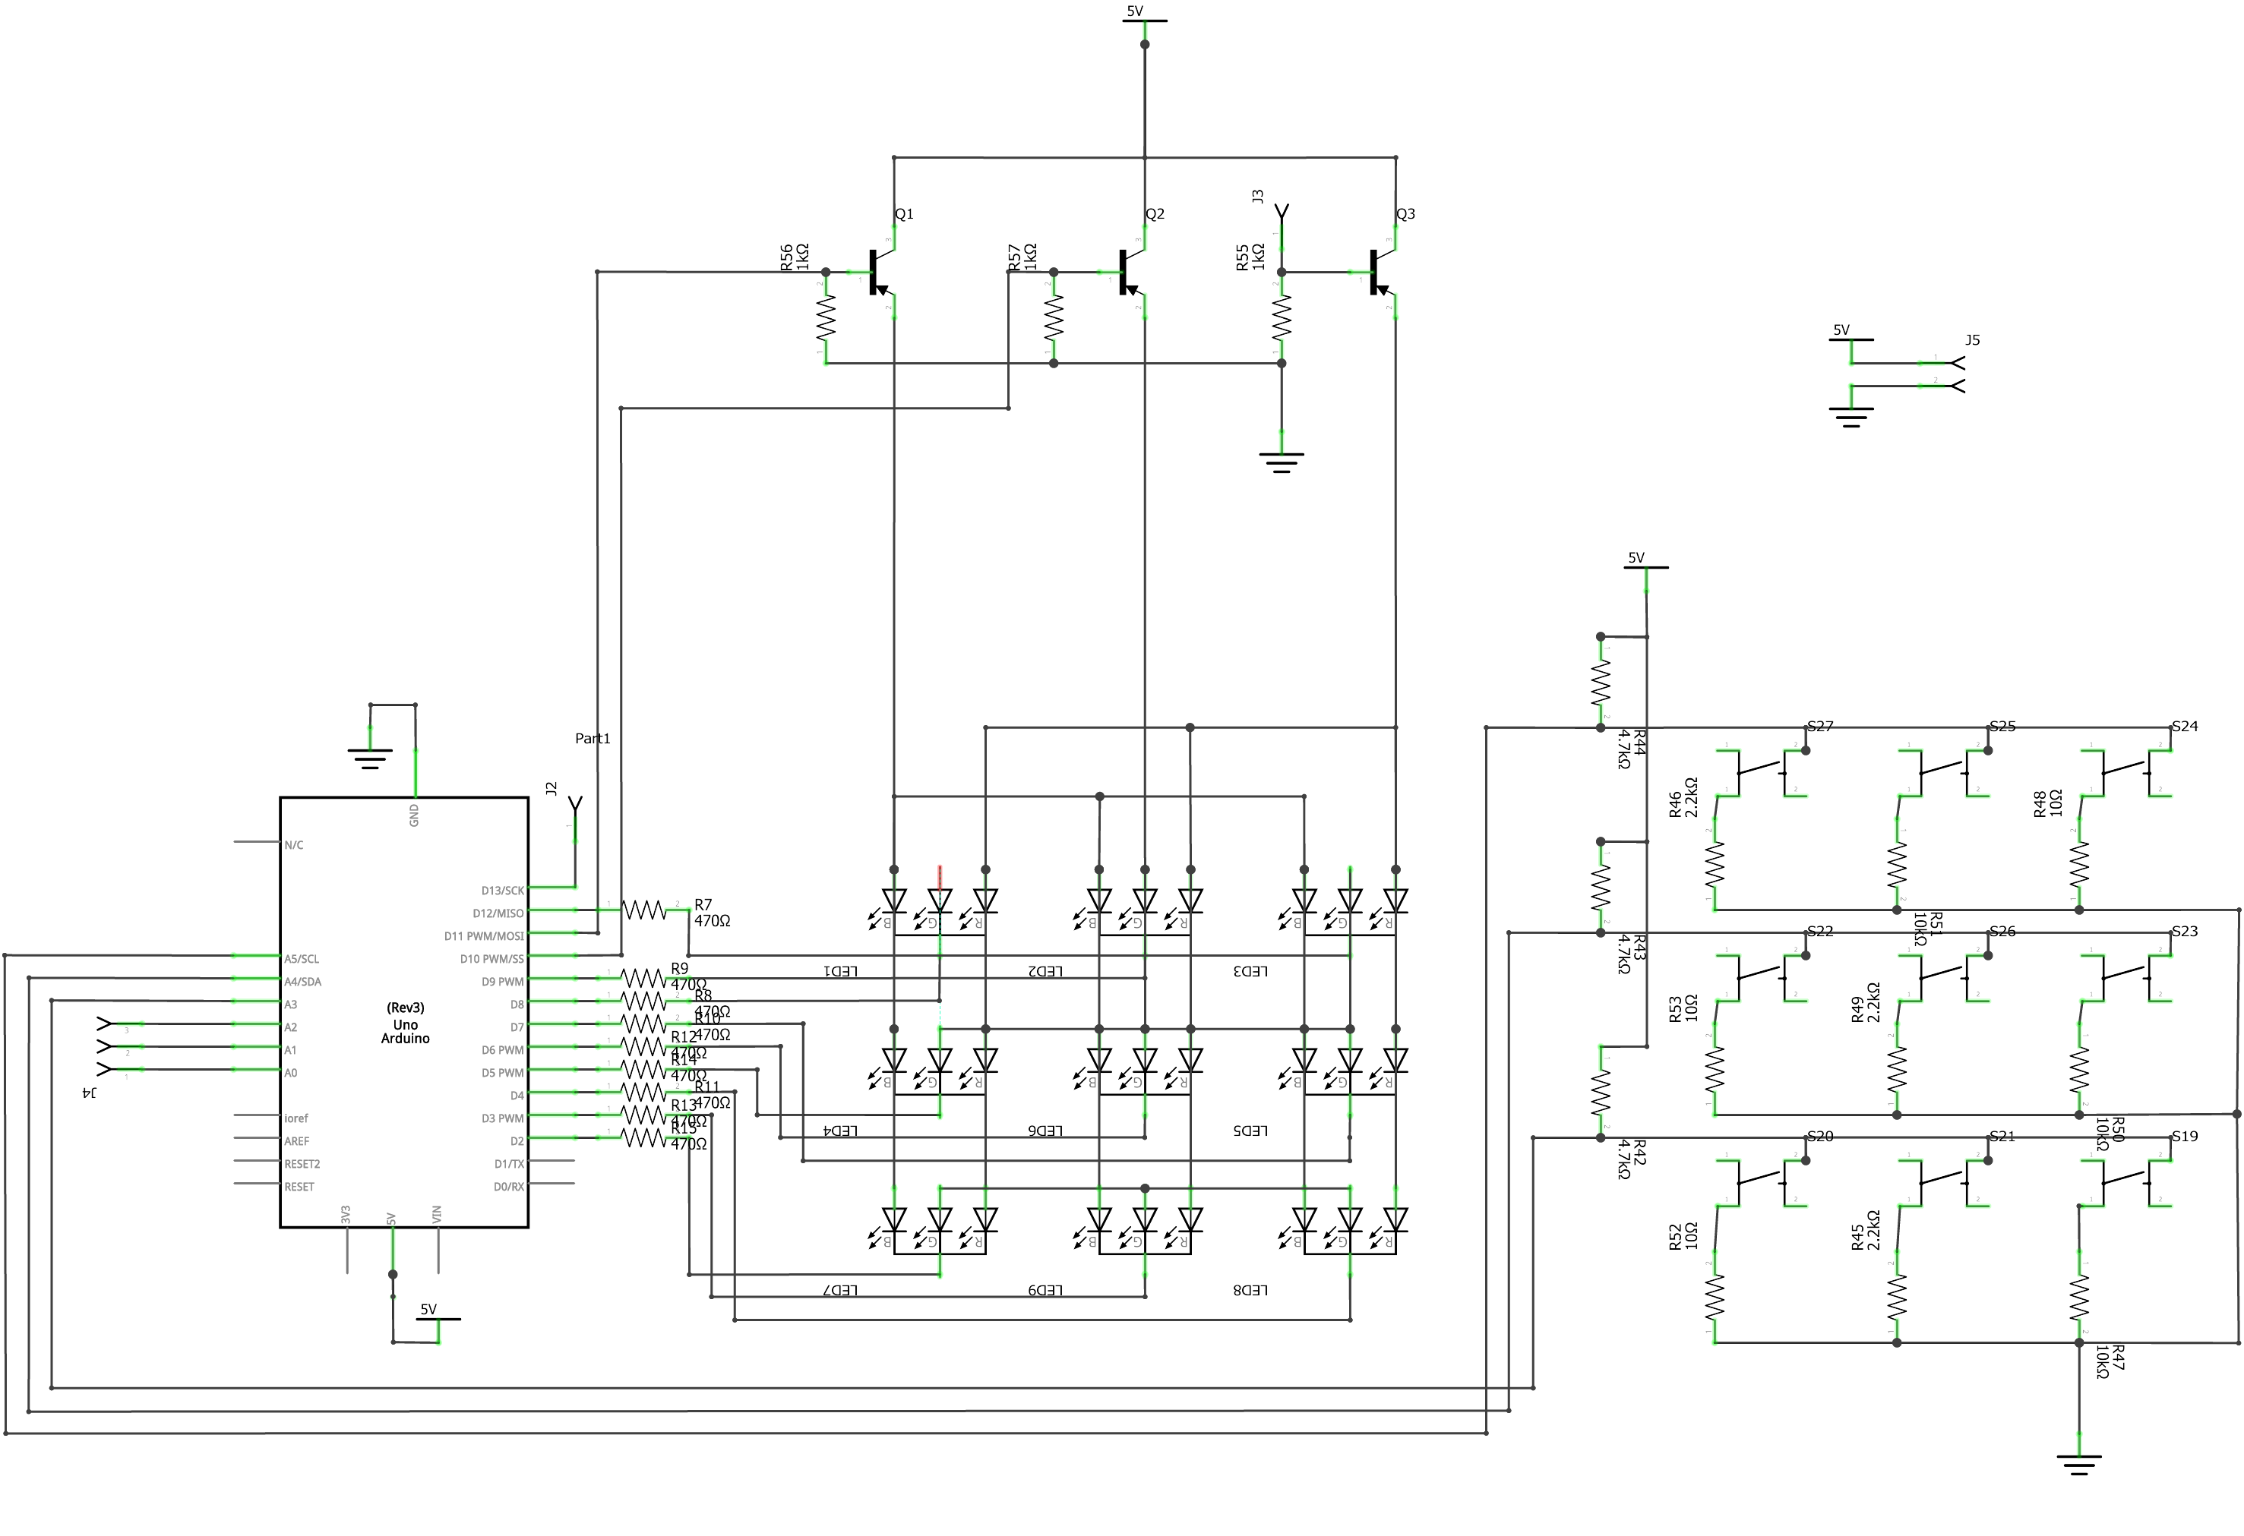

To turn on a LED, It is necessary to digital write logic low (0v) state to the LED pin and need to set logic high (5v) state to the base of the transistor which color we need.

*3.1 Controlling Button*

A voltage divider with 4 resistors are used to get 9 button inputs using only 3 analog pins. Circuit diagram, as shown below.

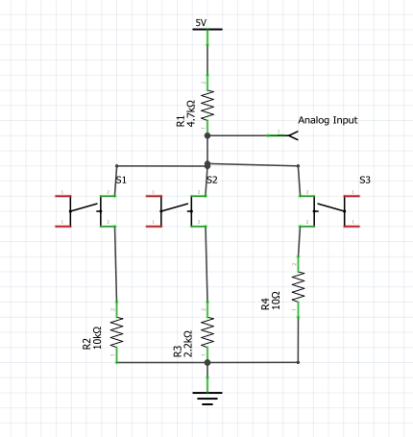

Resistor values are calculated according to the potential dividing method.

V0

***5. Reference***

* <https://arduino.cc>
* <https://en.wikipedia.org/wiki/Tic-tac-toe>
* <http://neverstopbuilding.com/minimax>